Manual Test Plan

1. static main interface

Double-Click on the Desktop Application Icon. You should see a profile Page.

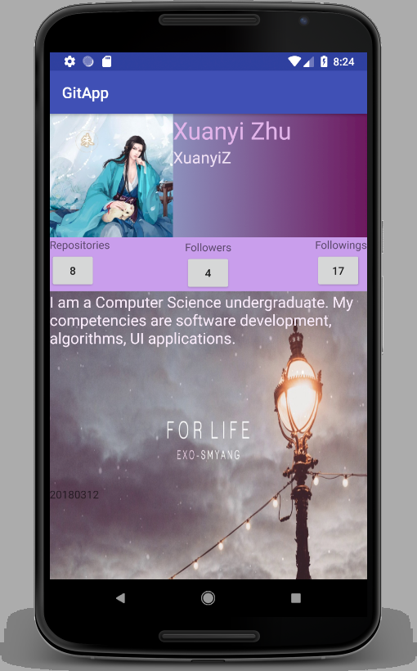

1. Testing the Repo Page

Click on the Repository button(the one with number). You should see a repository Page.

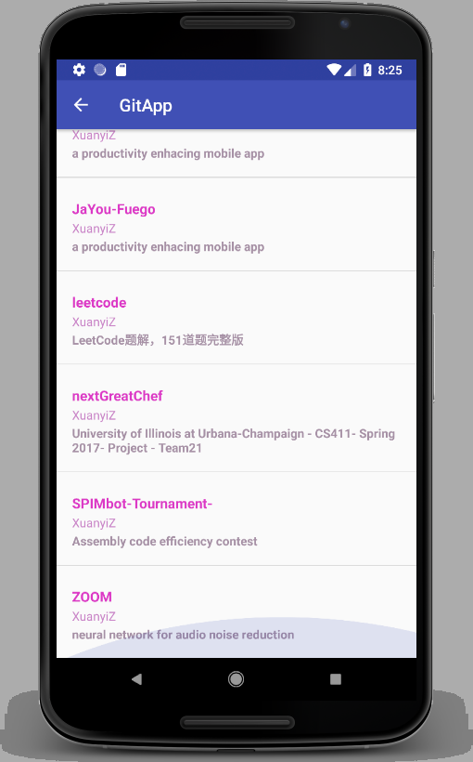

Nottice that I do not hard code the content. Rather, I successfully Interacting with Github API, fetching, parsing, storing and displaying the data into the application.

1. Test redirecting

by clicking any project item, you will be prompted and directed to the github website of that project. 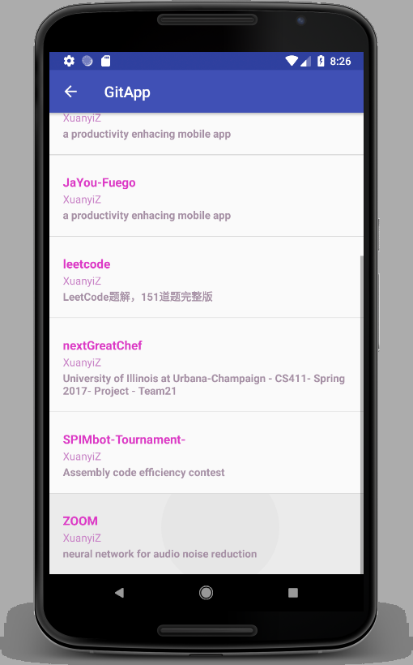

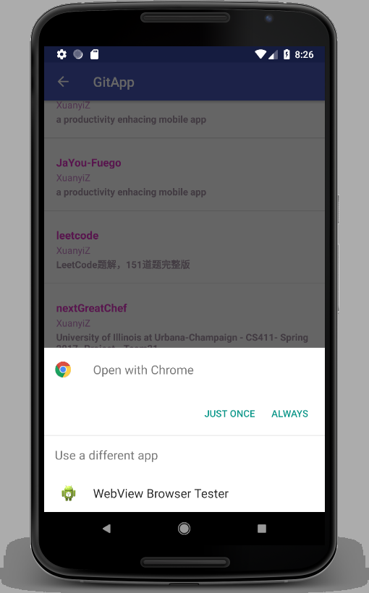

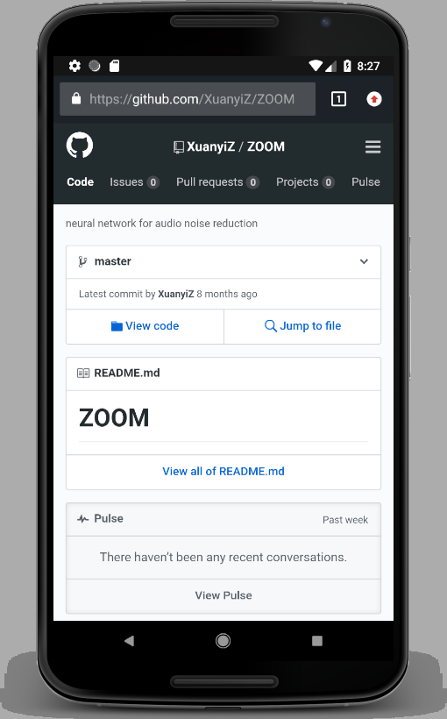

1. Test page navigating

By clicking the arrow key on upper left corner, u can navigate bettwen any pages.

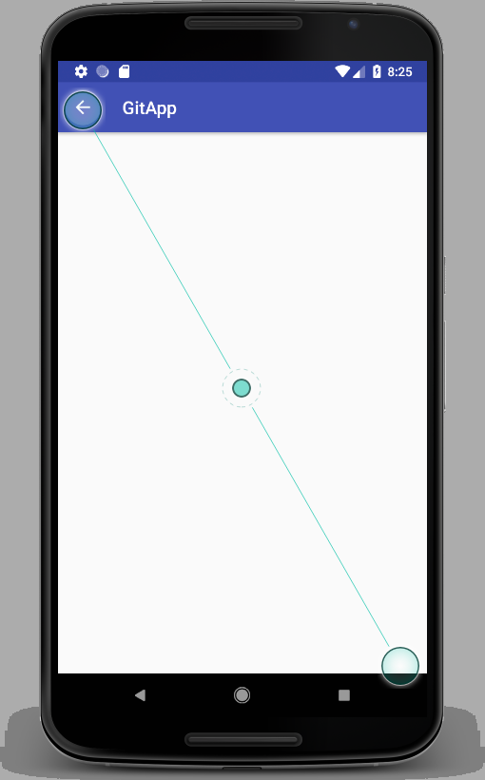

1. Test the Followings and Followers Page

Click on the Followings and Followers button. You should be redirected to a empty page.

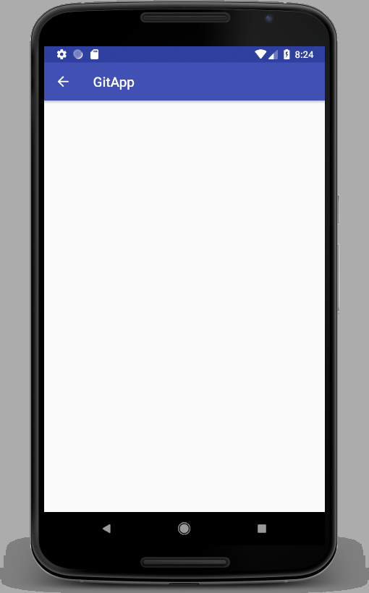

6.Test relative layout:

Because I used match parent ,wrap content or relative latout, etc...I achieve adaptive layout

<https://developer.android.com/training/multiscreen/screensizes.html>

By choosing different emulators, the app still work and visualize properly.

Now we switch to a different mobile phone with different screen size as above, the app still work and visualize properly.

